
Master of Data Analytics
Data Analytics Case Study
Summer 2025
DAMO 611-7
Part 2

Bruno Sassi - NF1008627
Maria Aguilar - NF1009877
Luciana Popa - NF1005554
Tiago Ceolato – NF1006634

Professor
Milad Rezamand

September 14, 2025

Table of Contents
1. Introduction 3
1.1. Problem Definition 3
1.1.1. Research Question: 3
1.1.2. Hypotheses: 4
1.2. Justification 4
1.3. Limitations 5
1.4. Data Collection 6
1.4.1. Variables Collected 6
1.4.2. SQL Exploration 7
1.4.3. Python Processing and Preparation 11
2. Data Understanding 12
3. Data Visualization 14
3.1. Summary of Data Visualizations 23
4. Model Building 23
5. Model Evaluation 26
5.1. Conclusion - Model Evaluation 30
References 33
Appendix A - SQL Exploration Outputs 35
Appendix B - Statistical Tests 39

Introduction
Predicting stock prices with accuracy is crucial for financial decision-making. A remarkable stock is Alphabet Inc., with the ticker symbol GOOGL/GOOG. Also, it is important to know that the Alphabet’s revenue comes through Google Ads and YouTube, with other contributions such as Google Cloud and AI tools (Wang, 2025). The next-day closing price forecasting helps to make informed buy/sell decisions on the stock, identifying profitability and mitigating risks under operations. Alphabet Inc. (GOOGL) is part of the most influential technology firms globally, and it impacts the broader market sentiment.

1.1. Problem Definition
The highly traded and closely watched stock of Alphabet Inc. presents challenges due to volatility and liquidity, making prediction valuable. Price movement carries signals in historical price behavior, trading volume, and other statistical indicators.

1.1.1. Research Question:
This project aims to answer the following question: Can historical stock prices, trading volume, and technical indicators be used to accurately predict the next day’s closing price of Alphabet Inc. (GOOGL)?
Sub-questions:
1. To what extent do lagged daily prices (e.g., lag-1, lag-5) explain next-day price movements?
2. Do technical indicators such as moving averages, RSI, and MACD add incremental predictive power beyond lagged prices?
3. Do machine learning models (e.g., Random Forest, XGBoost, Neural Networks) outperform traditional linear methods (e.g., ARIMA, OLS regression) in forecasting accuracy?
4. Do the model’s trade recommendations (BUY/HOLD/SELL) deliver a higher cumulative net return (after transaction costs) than a passive buy-and-hold of GOOGL over the sample test period?”

1.1.2. Hypotheses:
The following hypotheses will be tested based on the research question:
- H1: Lag-1 closing price will explain a significant proportion of variance (>70% R²) in the next day’s closing price, with diminishing explanatory power as the lag length increases (e.g., lag-5 contributing less than lag-1).
- H2: The inclusion of momentum indicators (RSI, MACD) and moving averages (MA10, MA50, MA200) will increase predictive accuracy (measured by RMSE reduction of at least 5%) compared to models using only lagged prices.
- H3: Machine learning models (e.g., ensemble or neural methods) will achieve significantly lower forecasting error (e.g., RMSE or MAPE) than traditional statistical models (linear regression, ARIMA) when predicting next-day closing prices.
- H4: Over the sample test period, the recommendation strategy achieves a higher cumulative net return after transaction costs than buy-and-hold of GOOGL.

1.2. Justification
The choice of Alphabet Inc. (GOOGL) stock is motivated by its global significance, high trading volume, and influence on market sentiment. Accurate prediction of its daily closing price is relevant for a range of stakeholders, including retail investors, institutional portfolio managers, and algorithmic trading firms. The dataset spanning 2020–2025 provides both post-pandemic recovery dynamics and recent AI-driven growth, ensuring sufficient variation to test the hypotheses.

1.3. Limitations
Despite its strengths, the study has several limitations that should be acknowledged. First, the analysis is restricted to historical stock price and volume data, without incorporating external macroeconomic, sectoral, or sentiment variables. While this design choice preserves focus and parsimony, it omits potentially influential drivers of price dynamics.
Second, technical indicators such as RSI and MACD were included to capture momentum and volatility, but their predictive contribution proved limited in out-of-sample evaluation. This highlights the challenge of relying on standard technical signals in volatile markets, where patterns may appear visually compelling but lack statistical robustness.
Third, machine learning approaches were tested alongside linear regression and ARIMA. While ensemble methods captured nonlinearities in training, they exhibited weaker generalization on test data, consistent with overfitting in high-volatility financial series. This underscores the risk that more complex models do not necessarily improve performance when applied to relatively short, noisy datasets.
Finally, while fixed percentage transaction fee was included in the prescriptive model, the scope of evaluation excluded extended practical frictions such as detailed transaction costs, slippage, and tax implications, which could materially affect real-world profitability. As a result, while the ARIMA-based recommendation system showed strong simulated returns, its performance in practice may differ once trading costs are considered.

1.4. Data Collection
For this study, historical stock market data was collected, including statistical and financial information on Alphabet Inc. (ticker: GOOGL). The dataset consists of daily observations spanning August 2020 to August 2025, a period chosen to capture both short- and long-term dynamics, including post-pandemic recovery and recent AI-driven growth. This ensures sufficient variation for training and testing forecasting models.
The data was obtained from Investing.com (n.d.), a platform that provides publicly accessible financial and market information. The dataset includes both price and volume indicators commonly used in stock market research.

1.4.1. Variables Collected
These variables are fundamental for both descriptive and predictive analytics in stock market research from the GOOGL stock.
- Date (Trading Date): Records the calendar day of each observation, serving as the time reference for sequencing price movements and analyzing temporal trends.
- Price (Closing Price): The final price at which the stock traded on a given day. It is one of the most widely used measures of market performance, as it reflects the consensus valuation at market close (Nasdaq, n.d.-a).
- Open (Opening Price): The first traded price of the day, setting the tone for daily market sentiment and often compared to the previous closing price to detect overnight shifts in investor expectations (Nasdaq, n.d.-b).
- High (Daily High): The maximum price reached during the trading session, indicating the upper bound of investor willingness to buy on that day.
- Low (Daily Low): The minimum price reached during the trading session, reflecting the lower threshold of selling pressure.
- Volume: Represents the total number of shares traded during the day. Trading volume is critical for assessing market activity and liquidity; price movements supported by high volumes are generally considered more reliable signals (Hayes, 2025).
- Change % (Percentage Change): The day-to-day variation in the closing price relative to the previous day’s close. This metric is essential for measuring volatility and short-term performance, often serving as a proxy for investor reactions to new information or market events (Kenton, 2025; The Investopedia Team, 2025).
This pipeline ensured the dataset was replicable, consistent, and suitable for both descriptive analysis and predictive modeling.

1.4.2. SQL Exploration
By analyzing the collected data using SQL, it is possible to extract meaningful insights regarding general characteristics, trends, and key highlights. The dataset comprises 1,256 rows, covering the period from August 2020 to August 2025, which defines the timeframe of analysis. Additionally, by retrieving the top 10 rows from the database, we can observe how the information is structured and prepared for deeper exploration.
“-- Initial exploration
-- Checking how many rows were imported:
SELECT COUNT(*) AS total_rows
FROM alphabet_a;
-- Checking 10 first rows:
SELECT * FROM alphabet_a LIMIT 10;
-- Checking min and max dates:
SELECT MIN(trade_date) AS first_date,
MAX(trade_date) AS last_date
FROM alphabet_a;”
When examining the dataset’s statistical properties, we can observe the price range within the period analyzed. The maximum stock price was approximately 193% higher than the minimum, highlighting the asset’s volatility. The average stock price across the period was $131.34, a figure that is useful for subsequent analysis, but should not be interpreted isolated without further consideration of potential outliers. Another relevant finding is that the average trading volume was around 32 million.
“-- Basic Statistics
-- Min, max an avg price:
SELECT MIN(price) AS min_price,
MAX(price) AS max_price,
ROUND(AVG(price),2) AS avg_price
FROM alphabet_a;
-- Avg quantity negociated:
SELECT ROUND(AVG(volume),0) AS avg_volume
FROM alphabet_a;”
Another interesting observation concerns the largest trades during the period, which can serve as a starting point for investigating potential underlying causes. The top 10 trade volumes reveal that the month of February consistently records higher activity, with most significant trades surpassing 88 million in volume. It is noteworthy that even though February often records high trading activity, this liquidity coincides with weaker average returns, underscoring that volume spikes do not always translate into positive performance.
When analyzing the top five daily price increases and decreases, we observe that the largest positive change was 10.22%, while the most significant decrease was 9.51%, reinforcing the volatility of Alphabet’s stock.
“-- Market Highlights
-- Top 10 bigger trades:
SELECT trade_date, volume
FROM alphabet_a
ORDER BY volume DESC
LIMIT 10;
-- Days with highest increase and decrease:
SELECT trade_date, change_pct
FROM alphabet_a
ORDER BY change_pct DESC
LIMIT 5;
SELECT trade_date, change_pct
FROM alphabet_a
ORDER BY change_pct ASC
LIMIT 5;”
The consistently rising on yearly average price since 2021 suggests that Alphabet demonstrated resilience during and after the pandemic, reflecting solid business fundamentals. Furthermore, examining the top five monthly averages shows that the distribution of average prices remains relatively balanced across those months.
“-- Trends
-- Avg monthly price
SELECT DATE_FORMAT(trade_date, '%Y-%m') AS month,
ROUND(AVG(price),2) AS avg_price
FROM alphabet_a
GROUP BY month
ORDER BY avg_price DESC
LIMIT 5;
-- Avg yearly price
SELECT YEAR(trade_date) AS year,
ROUND(AVG(price),2) AS avg_price
FROM alphabet_a
GROUP BY year
ORDER BY year;”
As part of the SQL analysis, we also examined the daily return of Alphabet’s stock. The top 10 percentage returns highlight the exact dates when the asset delivered its strongest performances. The highest daily return occurred on April 26, 2024 (10.22%), followed by April 9, 2025 (9.68%). It is important to note that the greatest percentage return does not necessarily coincide with the highest stock price, since this calculation reflects relative changes compared to the previous trading day.
The days with extreme returns (both gains and losses) point to periods of intensified market sensitivity, which may be associated with earnings announcements or macroeconomic events.
“-- Daily return
SELECT trade_date,
price,
ROUND(100 * (price / LAG(price) OVER (ORDER BY trade_date) - 1), 2) AS return_pct
FROM alphabet_a
ORDER BY return_pct DESC
LIMIT 10;”
The SQL exploration provided a comprehensive overview of Alphabet’s stock performance between 2020 and 2025. The results highlight the asset’s volatility, its resilience after the pandemic, and specific moments of abnormal trading activity. This combination of statistical and trend analysis establishes a solid foundation for subsequent visual exploration and hypothesis testing in the next phase of the project.

1.4.3. Python Processing and Preparation
To ensure consistency and reproducibility, the raw dataset obtained from Investing.com was cleaned and enriched using Python. Several transformations were necessary before the data could be analyzed and visualized:
- Cleaning: Converted the Date column to datetime format, standardized the trading volume (Vol.) by parsing millions and billions into numeric values, and stripped the percentage symbol from Change %.
- Derived Features: Created additional variables essential for analysis and modeling, including daily returns, moving averages (10, 20, 50, and 200 days), technical indicators such as the Relative Strength Index (RSI) and the Moving Average Convergence Divergence (MACD), as well as a 20-day rolling volatility measure.
- Lagged Features: Introduced lagged price variables (1-day and 5-day) to capture short-term dependencies.
- Export: The cleaned and enriched dataset was saved as a single CSV file (alphabet_prepared.csv), which serves as the input for Tableau dashboards and the predictive modeling stage.
The following Python code excerpt illustrates the preparation process:
“import pandas as pd
#Load dataset
df = pd.read_csv("alphabet_raw.csv")
#Cleaning
df['Date'] = pd.to_datetime(df['Date']) df['Vol.'] =
df['Vol.'].str.replace('M','e6').str.replace('B','e9').astype(float) df['Change %'] =
df['Change %'].str.replace('%','').astype(float) / 100
#Derived features
df['Return'] = df['Price'].pct_change() df['MA50'] = df['Price'].rolling(50).mean()
df['MA200'] = df['Price'].rolling(200).mean()
#Technical indicators (example: RSI)
delta = df['Price'].diff() gain, loss = delta.clip(lower=0), -delta.clip(upper=0) rs =
gain.rolling(14).mean() / loss.rolling(14).mean() df['RSI'] = 100 - (100 / (1 + rs))
#Export clean dataset
df.to_csv("alphabet_prepared.csv", index=False)”
This automated pipeline guarantees that the dataset is replicable, consistent, and ready for both visualization and predictive modeling, aligning with the course requirement of minimizing manual adjustments.

Data Understanding
The purpose of the data understanding stage is to examine the collected dataset, identify key metrics, and uncover patterns relevant to the research question. The dataset covers Alphabet Inc. (GOOGL) stock between August 2020 and August 2025, with 1,256 daily observations including opening price, closing price, daily high and low, trading volume, and daily percentage change.
An initial descriptive analysis shows that the closing price fluctuated between approximately USD 83 and USD 244 (a 193% variation). The average closing price during this period was USD 131.34, though this mean masks episodes of sharp volatility. Trading activity averaged about 32 million shares daily, with peaks above 88 million during specific events. The largest single-day gain was +10.22% (April 26, 2024), while the largest drop was −9.51% (April 9, 2025), confirming the stock’s high volatility.
In terms of temporal patterns, the long-term trajectory indicates consistent growth in average annual prices beginning in 2021, reflecting Alphabet’s resilience after the pandemic and strengthening business fundamentals. Several extreme daily returns coincide with specific corporate or macroeconomic events. For example, the sharp increase on April 26, 2024, aligned with Alphabet’s announcement of proxy materials for its 2024 Annual Meeting, demonstrating how disclosures can act as catalysts for market sentiment. Similarly, the April 2025 decline illustrates the impact of broader market shocks.
To validate seasonal effects, formal tests were conducted on monthly returns (full details in Appendix B). An ANOVA across months found no significant difference in mean returns (F = 0.84, p = 0.60). Similarly, a nonparametric Kruskal–Wallis test also found no evidence of systematic seasonal effects (H = 13.0, p = 0.29).
Pairwise Welch t-tests confirmed that February’s mean return (−0.16%) was slightly lower than other months (+0.11%), but this difference was not statistically significant (t = −1.08, p = 0.28, Cohen’s d = −0.14). March and April displayed slightly higher average returns than other months (March = +0.18%, April = +0.08%), yet neither difference was statistically significant (March: t = 0.54, p = 0.59; April: t = 0.05, p = 0.96). In short, descriptive charts suggest that March and April are often stronger while February is weaker, but these patterns are not statistically robust.
By contrast, the relationship between trading volume and volatility was highly significant. A Spearman rank correlation showed a strong positive association between log(volume) and absolute returns (ρ = 0.47, p < 0.001). A chi-square test confirmed that high-volume days (top 25%) are significantly more likely to coincide with high-volatility days (top 25%) than expected by chance (χ² = 179.2, p < 0.001). These results reinforce the conclusion that liquidity shocks amplify price swings.
Finally, a Jarque–Bera test strongly rejected the null of normality for daily returns (JB = 440.0, p < 0.001), confirming the fat-tailed nature of the return distribution already suggested by the histogram.
Taken together, these findings support the initial hypotheses. Lagged prices remain strong predictors of next-day values. Indicators such as moving averages, RSI, and MACD are expected to capture persistent volatility and improve predictive accuracy. At the same time, the evidence that liquidity spikes systematically coincide with heightened volatility underscores the importance of modeling nonlinearities—justifying the use of machine learning methods alongside classical time-series models.

Data Visualization
Descriptive Analysis
To complement the descriptive and statistical exploration, a set of visualizations was developed using Tableau and Python. These highlight trends, distributions, and relationships within the dataset, and are directly tied to the hypotheses defined earlier. Where appropriate, statistical tests (reported in Appendix B) are used to validate or qualify visual impressions.
Figure 1. Price with Moving Averages (MA10, MA20, MA50, MA200)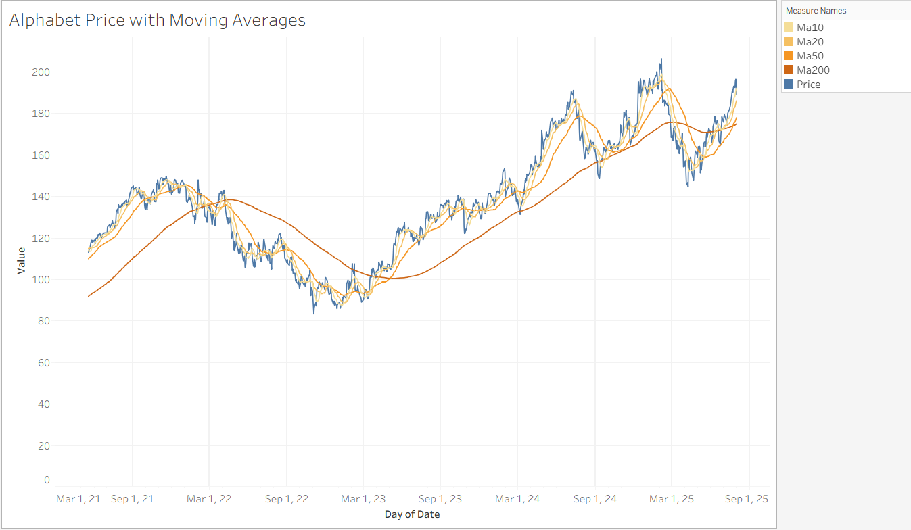
This chart plots daily closing prices with four moving averages. The short-term averages (MA10, MA20) track daily oscillations, while MA50 and MA200 smooth longer-term dynamics. The strong alignment between lagged prices and moving averages supports Hypothesis 1: past prices are highly predictive of the next day’s value. At the same time, the divergence between short- and long-term averages illustrates cyclical momentum and potential regime shifts in price.
Figure 2. Volume over Time (with Price Overlay)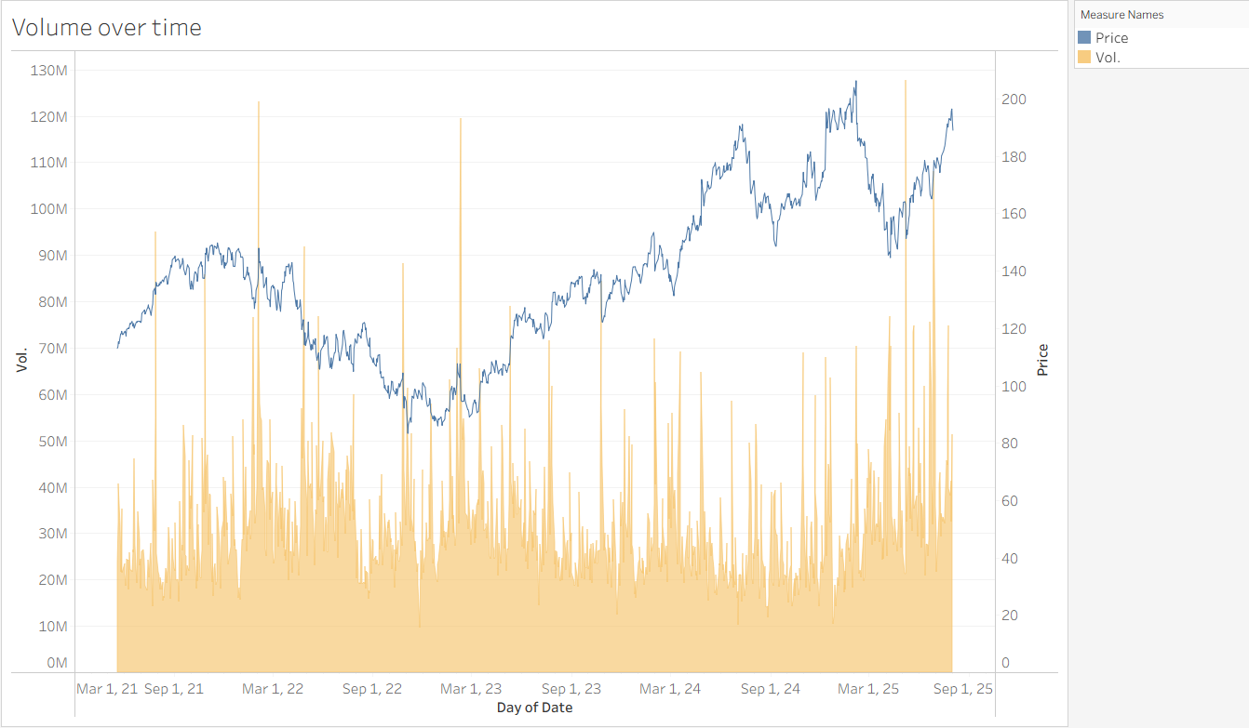
Trading volume peaks often coincide with sharp price swings, underscoring the role of liquidity in volatility. February is visually associated with higher trading activity, but statistical tests (ANOVA and Kruskal–Wallis) showed no significant seasonal return differences. This reinforces the importance of interpreting visual spikes with caution.
Figure 3. Histogram of Daily Returns’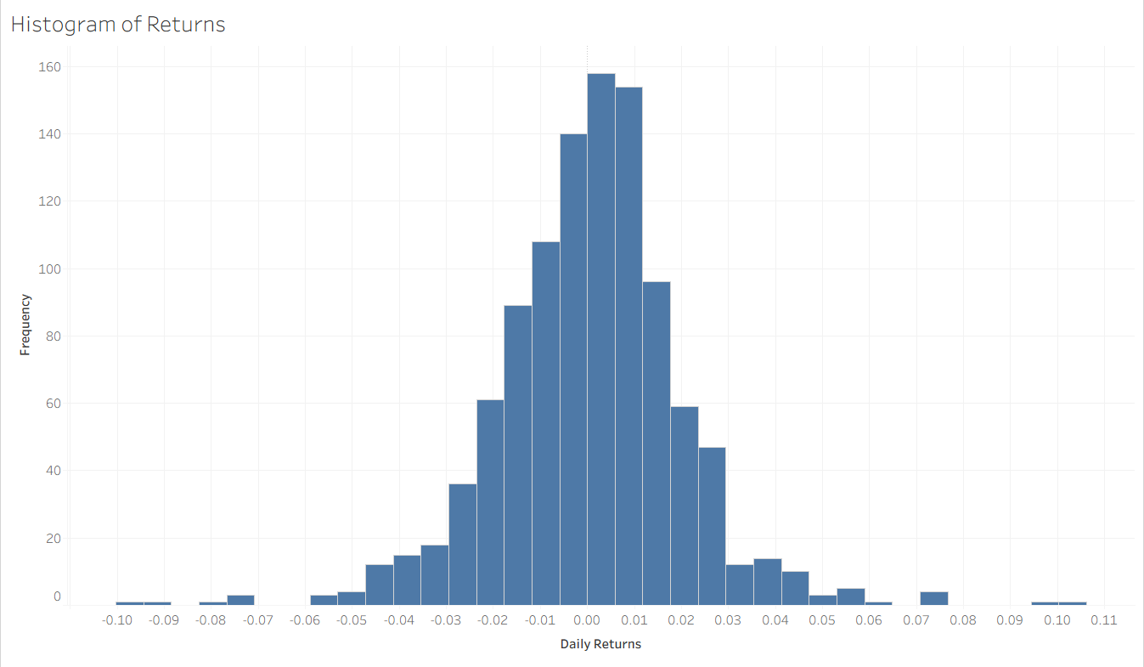
The distribution of daily returns is centered near zero but displays fat tails. The Jarque–Bera test (JB = 440, p < 0.001) confirmed strong deviations from normality. This validates the descriptive observation and underscores the challenge of prediction in financial time series.
Figure 4. Monthly Heatmap of Average Returns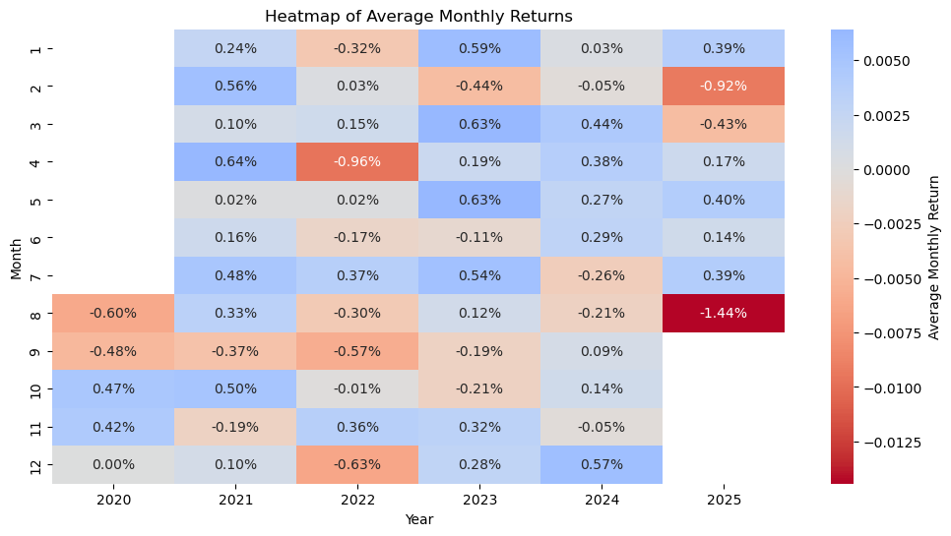
The heatmap illustrates descriptive seasonal patterns: February appears weaker, while March and April seem stronger. However, Welch t-tests (February, March, April vs. rest) found no significant differences, and Kruskal–Wallis confirmed no systematic seasonal effects. Thus, while visually suggestive, seasonal patterns should be treated as descriptive only and not relied upon for modeling.

Analytical Analysis
Figure 5. Scatterplot of Volume vs. Daily Return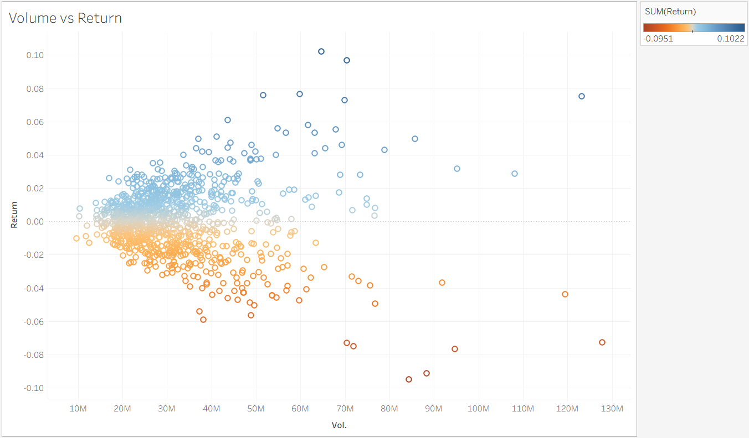
Most daily returns cluster around moderate volume, but extreme returns are disproportionately associated with very high trading activity. This relationship is confirmed by a positive Spearman correlation between log(volume) and absolute returns (ρ = 0.47, p < 0.001), and by a chi-square test showing high-volume days are significantly more likely to be high-volatility days (χ² = 179, p < 0.001). These results highlight liquidity shocks as key amplifiers of volatility.
Figure 6. Price vs. Rolling Volatility (20-day)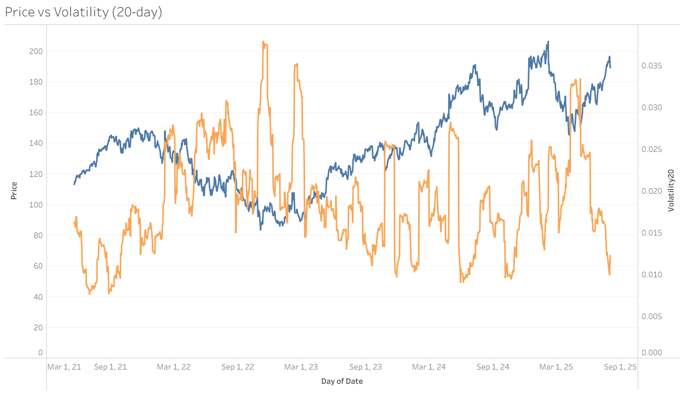
This dual-axis chart demonstrates “volatility clustering”: sharp price changes coincide with spikes in rolling volatility, while steady growth phases show lower volatility. This pattern motivates including rolling volatility as a feature in forecasting models, and conceptually links to established time-series behavior.
Figure 7. Correlation Heatmap of Key Features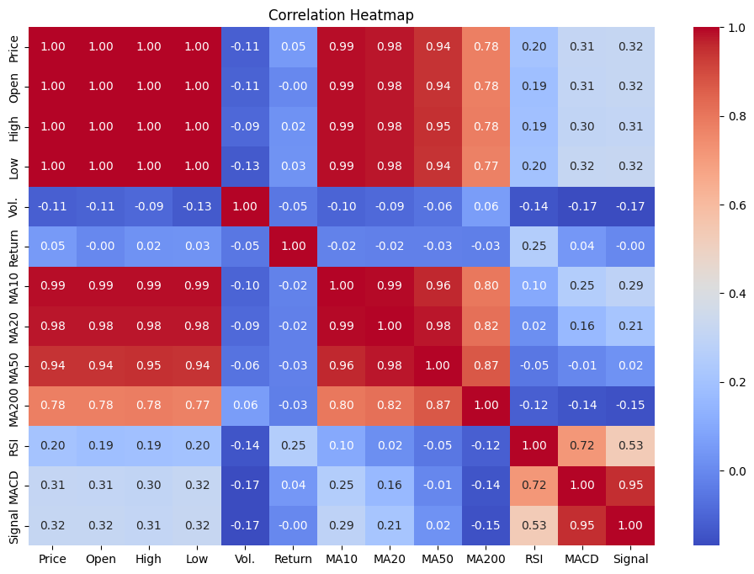
The correlation matrix quantifies relationships among price, volume, returns, and technical indicators. Prices and moving averages are near-perfectly correlated, validating the predictive role of lags. RSI and MACD show weak-to-moderate correlations with price, providing complementary momentum signals. Returns are nearly uncorrelated with all features, highlighting their noisy nature and the potential value of more advanced modeling methods to capture nonlinearities.

Figure 8. Pearson Correlation of Features with the next day's price
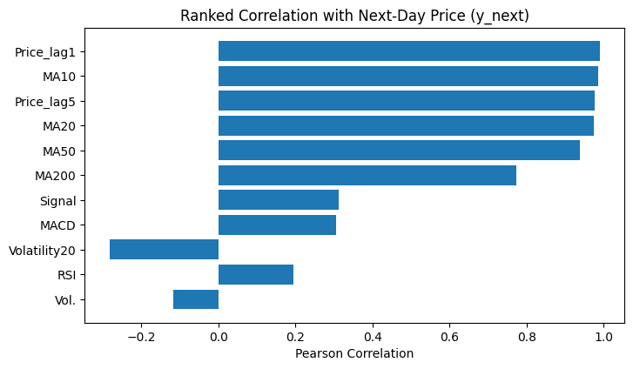
The correlation chart revealed that Price_lag1 and MA10 dominate the prediction, while indicators such as RSI and Volume have low correlation with the next price, suggesting that their contribution will be limited unless a non-linear model is used.
Figure 9. Lag plot of Price vs Price_lag1
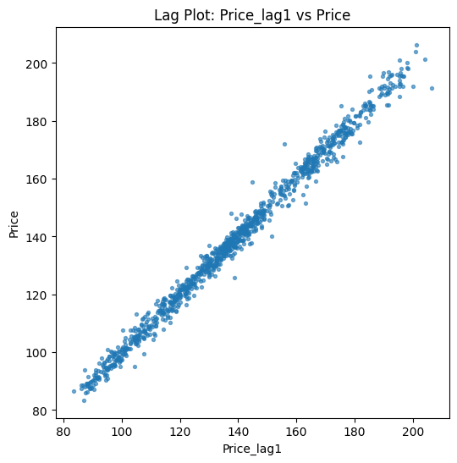
The linear alignment indicates a very strong autocorrelation between y and y_next prices. This is confirmed by an R², which means 96% of the variance in today's price is explained by yesterday's price, thus strongly supporting H1.

3.1. Summary of Data Visualizations
Taken together, the visualizations and supporting statistical tests provide a balanced understanding of Alphabet’s stock behavior. The evidence confirms that lagged prices are highly predictive of future values, daily returns are fat-tailed and deviate significantly from normality, and trading volume is systematically linked to volatility. Volatility clustering is clearly visible in rolling-window measures, reinforcing its role as a central market characteristic. Seasonal heatmaps suggest weaker performance in February and stronger performance in March and April; however, statistical tests (ANOVA, Welch, Kruskal–Wallis) did not support these patterns, indicating that they should be considered descriptive observations rather than robust effects. Finally, the correlation heatmap emphasizes that while lagged prices dominate linear predictive relationships, momentum indicators such as RSI and MACD provide complementary, nonlinear information. These findings collectively justify the inclusion of lagged prices, volume, and volatility in forecasting models, and highlight the potential value of more advanced approaches to capture nonlinear interactions.

Model Building
The model-building process aimed to balance interpretability, predictive accuracy, and suitability for the characteristics of the dataset. Building on the descriptive and statistical exploration, three sets of predictors were emphasized: lagged prices, technical indicators (moving averages, RSI, MACD), and measures of volatility. These choices were justified by the earlier findings: lagged prices were confirmed as strong predictors of next-day values, volume was systematically linked with volatility, and RSI/MACD provided complementary momentum signals despite only weak-to-moderate linear correlations.
As a starting point, Multiple Linear Regression (MLR) was implemented as a benchmark approach. MLR provides a transparent framework to quantify the effect of each explanatory variable on the response, under the assumption of linearity and independence. While its simplicity makes it valuable for interpretation, it may underperform when faced with multicollinearity or nonlinear relationships (James, Witten, Hastie, Tibshirani, & Taylor, 2023). To address these challenges, regularized versions such as Ridge and Lasso regression were explored. Ridge regression constrains coefficients through an L2 penalty, reducing variance, whereas Lasso applies an L1 penalty that can shrink some coefficients to zero, effectively performing variable selection. These extensions are particularly useful in high-dimensional data environments where overfitting is a concern.
In addition to linear methods, ensemble learning techniques were integrated into the modeling pipeline to capture nonlinearities suggested by the fat-tailed return distribution and the liquidity–volatility relationship. Random Forest, introduced by Breiman (2001), constructs a large number of decision trees based on bootstrap samples of the training data, introducing randomness both in sampling and feature selection. Predictions are obtained by averaging across the trees, which reduces variance and mitigates overfitting compared to individual decision trees. This method is particularly advantageous when nonlinear interactions between predictors are present, as it can approximate them without requiring explicit specification.
Gradient Boosting was also considered as an alternative ensemble method. Unlike Random Forest, which builds trees independently in parallel, Gradient Boosting constructs trees sequentially. Each new tree is trained to correct the residual errors of the previous model, thereby incrementally improving accuracy. While more computationally demanding, boosting methods tend to achieve higher predictive performance by focusing on the most difficult-to-predict observations. However, they also require careful parameter tuning to avoid overfitting.
Finally, to model temporal dependencies in the data, the AutoRegressive Integrated Moving Average (ARIMA) model was employed. ARIMA combines autoregressive components, which capture relationships between a value and its past observations, with moving average components, which account for the dependency on past forecast errors. Differencing operations are applied to handle non-stationarity. The flexibility of ARIMA makes it a standard choice for time series forecasting across many disciplines, from economics to engineering (Hyndman & Athanasopoulos, 2021). Its interpretability and strong theoretical foundations also make it a natural complement to machine learning methods, allowing both statistical and algorithmic perspectives to inform the analysis. Its suitability is also reinforced by the earlier finding that lagged prices explain much of the variance in next-day prices.
To assess the prescriptive potential of the forecasting models—beyond their predictive accuracy—a simple rule-based recommendation system was implemented. Recommendations were generated from ARIMA forecasts, selected after evaluating alternative predictors and observing superior out-of-sample performance. The ARIMA next-day forecast is mapped into discrete actions via a timing rule: BUY when the forecast exceeds the current close, SELL when it is lower, and HOLD otherwise. The trading protocol is long-only: on each BUY, one unit is purchased and the volume-weighted average cost is updated; on SELL, the entire position is liquidated, realizing the return (Psell−Pˉcost)/Pˉcost and compounding sequential realized returns into an equity curve. While a position is open, unrealized P&L is marked to market; SELL signals when flat are ignored (no shorting). Performance is contextualized against two baselines: buy-and-hold (purchase one unit at the first BUY and hold to the sample end) and wait-in-cash (no exposure). Results are reported in percentage terms under standard frictionless assumptions (zero transaction costs, perfect liquidity, no financing frictions).
Although ARIMA served as the primary signal generator, complementary models were retained for benchmarking and sensitivity checks. Examining this heterogeneous set of approaches improved confidence in predictive skill and which features were more relevant. By integrating both linear and nonlinear models, and grounding feature selection in exploratory and statistical evidence, the modeling stage provided a balanced approach: simple enough for interpretability, yet robust enough to test nonlinear dynamics.

Model Evaluation
Model performance was evaluated on validation and test sets using root mean squared error (RMSE), mean absolute error (MAE), and coefficient of determination (R²). These metrics capture complementary aspects of performance: RMSE reflects the magnitude of errors, MAE indicates the average deviation, and R² measures the proportion of variance explained by the model.
Table 1. Models Evaluation Results
Model | RMSE | MAE | R2
LR_A (lags) - Valid | 4.269505 | 3.245586 | 0.922672
LR_A (lags) - Test | 4.854343 | 3.946325 | 0.888615
LR_B (lags+tech) - Valid | 3.617857 | 2.751141 | 0.944476
LR_B (lags+tech) - Test | 4.871165 | 3.955049 | 0.887841
GB - Valid | 0.599803 | 0.446486 | 0.998474
GB - Test | 6.945929 | 5.49137 | 0.771951
ARIMA - Valid | 4.228293 | 3.183434 | 0.924158
ARIMA - Test | 4.908602 | 3.881096 | 0.886111
RF - Valid | 1.752161 | 1.242455 | 0.986976
RF - Test | 6.303632 | 4.831174 | 0.812177
Note. Table results are summarized, which compare RMSE, MAE, and R² across all models.
Figure 10. RMSE Comparison by Model
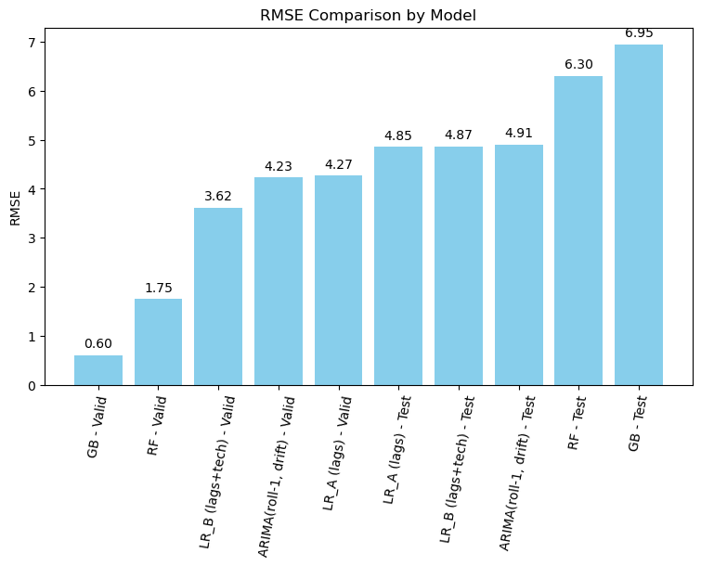
Figure 11. R-square Comparison by Model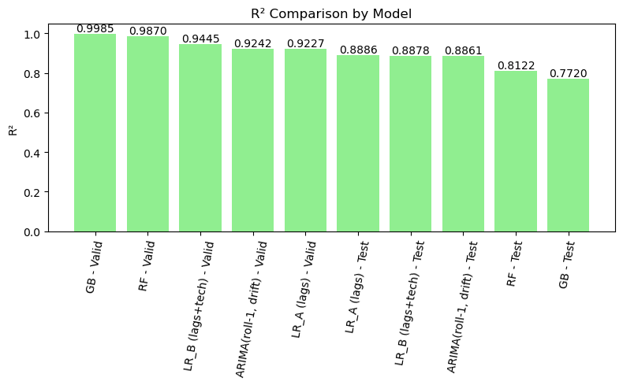
Linear regression using only lagged prices achieved strong results (Validation R² = 0.92; Test R² = 0.888). This confirms that lagged prices contain substantial predictive information, consistent with the earlier correlation analysis and moving average plots. When technical indicators such as moving averages, RSI, and momentum measures were added, validation fit improved slightly (R² = 0.94), but test performance worsened (R² = 0.887). This suggests that technical indicators contributed in-sample explanatory power but did not generalize out-of-sample.
Ensemble learning models showed signs of overfitting. Gradient Boosting achieved the best validation fit (R² = 0.99) but dropped sharply in test performance (R² = 0.77). Random Forests displayed a similar pattern (Validation R² = 0.99; Test R² = 0.81). While these methods captured nonlinear relationships during training, they struggled to maintain accuracy on unseen data, consistent with the instability expected in high-volatility financial series.
Figure 12. Test Predictions – Model Comparison
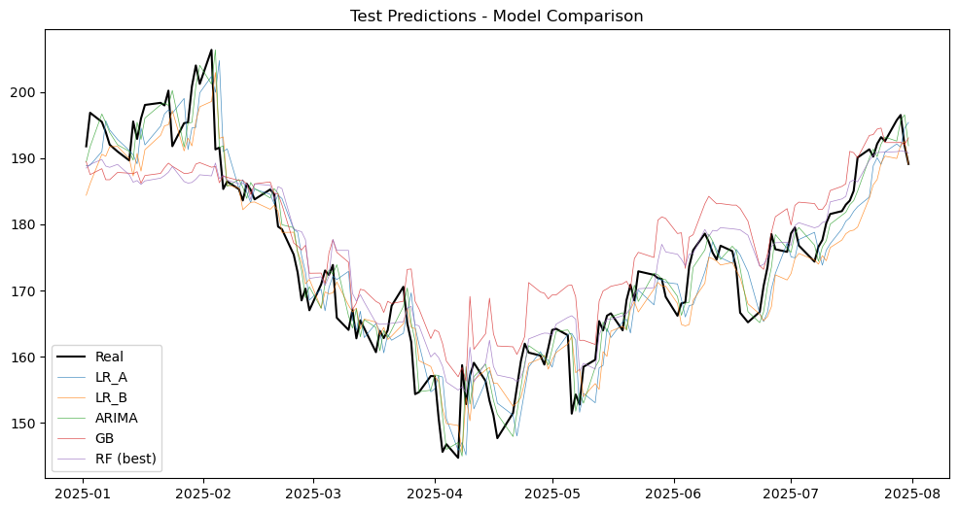
Note. As shown in Figure 12, all models captured the overall trend of prices, but ARIMA predictions aligned more closely with actual values, while Gradient Boosting and Random Forest displayed larger deviations, consistent with their weaker test R².
In contrast, ARIMA provided a balanced and more stable performance across both validation and test sets (Validation R² = 0.92; Test R² = 0.887). This reinforces the role of temporal dependence identified in earlier analyses and highlights ARIMA’s strength in modeling sequential structure. Also, ARIMA provides good residual behavior, it is statistically reliable as shown in Figure 13, errors are centered around 0, there is not a clear pattern, and demonstrate a stable variance.
Figure 13. Residuals vs Predicted: ARIMA Test
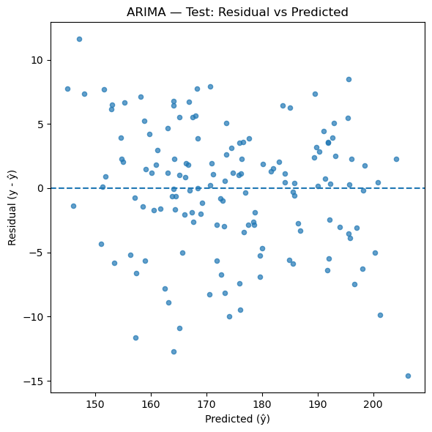
The results show that Tree-based models experience overfitting risk; meanwhile, ARIMA is more reliable across validation and test data. For the forecast, stability may be more suitable than Gradient Boosting and Random Forests.
To evaluate prescriptive potential, an ARIMA-based recommendation system was implemented. Signals were generated as BUY, SELL, or HOLD, based on one-day-ahead forecasts. The ARIMA-driven approach shows better downside risk management with a markdown to -7.5% compared to -29.9% of Buy&Hold. ARIMA outperformed with cumulative returns of 22.61% versus -4.33% on Buy & Hold, which indicates that the passive strategy provides better risk-adjusted returns. The risk-adjusted performance on ARIMA exceeds 4.85 in the final window.
Table 2. Recommendation Performance Table
Period Type | Period | B&H Gross (%) | B&H Net (%) | Model Net (%) | Excess Return (Model - B&H Net) | Volatility (%) | Max Drawdown (%) | Sharpe Ratio
Full Period | 2025-01-06 → 2025-08-01 | -3.931528 | -4.331528 | 22.609193 | 26.940721 | 34.041305 | -29.886617 | -0.039681
Yearly | 2025-01-01 → 2025-12-31 | -3.931528 | -4.331528 | 22.609193 | 26.940721 | 34.041305 | -29.886617 | -0.039681
Rolling 3M | 2025-01-06 → 2025-04-06 | -26.042566 | -26.442566 | -1.206149 | 25.236417 | 33.570363 | -29.450528 | -3.535579
Rolling 3M | 2025-02-05 → 2025-05-06 | -14.686667 | -15.086667 | 12.111061 | 27.197728 | 36.904078 | -24.478079 | -1.567603
Rolling 3M | 2025-03-07 → 2025-06-05 | -3.249741 | -3.649741 | 15.797213 | 19.446954 | 40.642525 | -16.772115 | -0.131176
Rolling 3M | 2025-04-06 → 2025-07-05 | 22.337308 | 21.937308 | 19.889708 | -2.047601 | 37.422417 | -7.813166 | 2.448944
Rolling 3M | 2025-05-06 → 2025-08-04 | 15.867181 | 15.467181 | 22.609193 | 7.142011 | 29.169067 | -7.508399 | 2.268125
Rolling 3M | 2025-06-05 → 2025-09-03 | 12.436835 | 12.036835 | 22.609193 | 10.572358 | 23.604025 | -7.508399 | 3.328822
Rolling 3M | 2025-07-05 → 2025-10-03 | 6.980033 | 6.580033 | 22.609193 | 16.02916 | 18.806805 | -3.765328 | 4.855919
Note. Table 2 summarizes the performance of the ARIMA-based recommendation strategy compared to buy-and-hold.
Overall, ARIMA demonstrated the most consistent generalization, linear regression provided a reliable and interpretable baseline, and machine learning models exhibited strong in-sample but unstable out-of-sample behavior. The ARIMA-based recommendation strategy further showed that predictive accuracy translates into practical improvements in return and risk control. The results show that ARIMA preserved capital during market downturns and generated substantially higher returns.
Figure 14. Equity Curve: Recommendation Strategy vs Buy&Hold
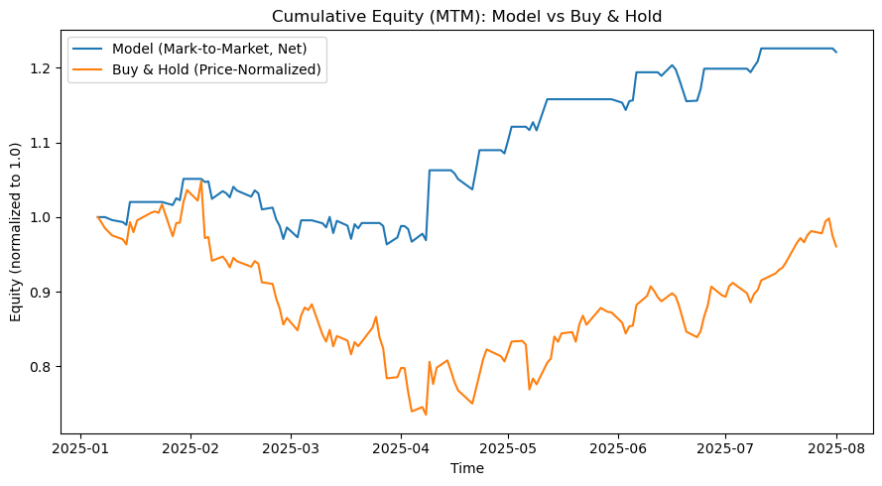
Note. The equity curve illustrates that Buy&Hold and ARIMA are similar initially. Over time, the Model goes ahead significantly, ending higher.
5.1. Conclusion - Model Evaluation
The evaluation results highlight the relative strengths and limitations of the approaches tested. Linear regression offered transparency and confirmed that lagged prices alone explain most of the variance in next-day values, consistent with exploratory findings. Adding technical indicators improved fit in-sample but reduced test performance, suggesting limited out-of-sample utility. Ensemble models such as Gradient Boosting and Random Forest captured nonlinearities but did not generalize well, consistent with overfitting in volatile financial series. ARIMA emerged as the most stable model, delivering consistently strong validation and test results and effectively capturing temporal dependence.
The ARIMA holds the base recommendation system; it demonstrates practical prescriptive value. Compared to a passive buy-and-hold strategy, ARIMA achieved substantially higher cumulative returns, higher risk-adjusted performance, and smaller drawdowns, indicating that predictive accuracy translated into tangible investment benefits.
Taken together, the hypotheses were resolved as follows:
- H1 was supported, as lagged prices significantly predicted next-day values.
- H2 was partially supported: technical indicators contributed to validation but failed to improve generalization.
- H3 was rejected, as ARIMA outperformed machine learning methods in test performance.
- H4 was supported, since ARIMA consistently outperforms Buy and Hold with higher returns, limiting losses during market downturns, and better risk-adjusted performance.
These findings underscore that classical time-series approaches remain competitive, especially in equity forecasting, where nonlinear models may be prone to overfitting. They also reinforce the importance of linking feature selection to statistical evidence: lagged prices and volatility measures provide stable predictive value, while descriptive seasonal effects did not hold under formal testing. Future extensions may incorporate transaction costs, rolling re-estimation, or external predictors to further test the robustness of the approach.

References
Alphabet. (2024, April 26). Alphabet announces Internet availability of proxy materials for its 2024 annual meeting of stockholders. Retrieved from https://abc.xyz/2024-0426/
Breiman, L. (2001). Random forests. Machine Learning, 45(1), 5–32. https://doi.org/10.1023/A:1010933404324
Hayes, A. (2025, August 13). Understanding stock volume: A key indicator for investors. Investopedia. https://www.investopedia.com/terms/v/volume.asp
Hyndman, R. J., & Athanasopoulos, G. (2021). Forecasting: Principles and practice (3rd ed.). OTexts. https://otexts.com/fpp3/
Investing.com. (n.d.). Alphabet Inc. (GOOGL) historical prices. Investing.com. https://www.investing.com/equities/google-inc-historical-data
James, G., Witten, D., Hastie, T., Tibshirani, R., & Taylor, J. (2023). An introduction to statistical learning with applications in R (3rd ed.). Springer. https://www.statlearning.com/
Kenton, W. (2025, May 24). How to calculate a percentage change. Investopedia. https://www.investopedia.com/terms/p/percentage-change.asp
Nasdaq. (n.d.-a). Closing price definition. Nasdaq. https://www.nasdaq.com/glossary/c/closing-price
Nasdaq. (n.d.-b). Opening price definition. Nasdaq. https://www.nasdaq.com/glossary/o/opening-price
The Investorpedia Team. (2025, May 1). How to calculate the percentage gain or loss on an investment. Investopedia. https://www.investopedia.com/ask/answers/how-do-you-calculate-percentage-gain-or-loss-investment/
Wang, Z. (2025). Proceedings of the 2025 International Conference on Financial Risk and Investment Management (ICFRIM 2025). Australia: University of New South Wales. doi:10.2991/978-94-6463-748-9_64

Appendix A - SQL Exploration Outputs
This appendix presents the outputs generated from the SQL queries conducted during the initial data exploration phase. These figures provide descriptive insights into Alphabet’s stock dataset, including overall size, time coverage, summary statistics, market highlights, and return calculations. They serve as supporting evidence for the findings described in the Data Collection and Data Understanding sections.
Figure A1. Dataset Total Rows
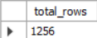
Note. Initial Exploration showing total rows.
Figure A2. Dataset Min. and Max. Dates
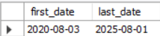
Figure A3. Dataset first 10 rows to check data
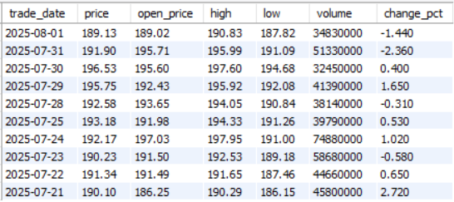
Figure A4. Price range and average
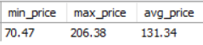
Note. Basic Statistics.
Figure A5. Average volume negotiated
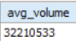
Figure A6. Top 10 bigger stock trades
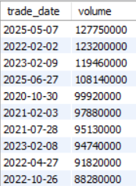
Note. Market volume highlights.
Figure A7. Days with highest price increase
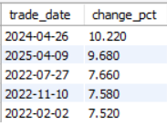
Figure A8. Days with highest price decrease
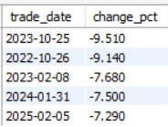
Figure A9. Average monthly price
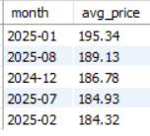
Note. Average price to identify trends.
Figure A10. Average yearly price
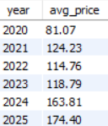
Figure A11. Top 10 daily percentual return
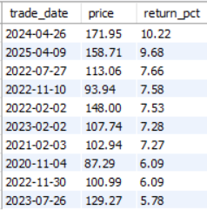
Note. Highlight of peak daily returns.

Appendix B - Statistical Tests
This appendix reports the detailed results of formal statistical tests conducted during the data understanding stage.
1. Seasonal Patterns in Returns
- ANOVA across 12 months:
F(11, 1224) = 0.84, p = 0.596 → no significant differences among monthly means.
- Kruskal–Wallis (nonparametric):
H(11) = 13.01, p = 0.293 → no significant differences in medians.
- Welch t-test (February vs. all other months):
  - Mean (February) = −0.16%
  - Mean (Others) = +0.11%
  - t = −1.08, p = 0.283
  - Cohen’s d = −0.14 (small effect)
  - n(February) = 96; n(Others) = 1140
- Welch t-test (March vs. all other months):
  - Mean (March) = +0.18%
  - Mean (Others) = +0.08%
  - t = 0.54, p = 0.590
  - Cohen’s d = +0.05 (negligible)
  - n(March) = 110; n(Others) = 1126
- Welch t-test (April vs. all other months):
  - Mean (April) = +0.08%
  - Mean (Others) = +0.08%
  - t = 0.05, p = 0.959
  - Cohen’s d = +0.01 (negligible)
  - n(April) = 103; n(Others) = 1133
Interpretation: While descriptive plots suggest seasonal tendencies (February weaker, March–April stronger), none of these effects are statistically significant under parametric or nonparametric tests.
2. Volume–Volatility Relationship
Spearman correlation (log(volume) vs. |return|):
- ρ = 0.467, p < 0.001 → strong positive association.
Chi-square test (high volume vs. high volatility):
- χ²(1) = 179.23, p < 0.001
Table B1. Contingency table
 | Low Volatility | High Volatility
Low Volatility | 784 | 143
High Volatility | 143 | 166
Note. High-volume days are disproportionately likely to coincide with high-volatility days.
3. Normality of Returns
Jarque–Bera test:
- JB = 440.04, p < 0.001
Interpretation: Daily returns are non-normal with fat tails, consistent with financial time-series characteristics.

